|  |  |
| --- | --- |
| Name: | Saksham Rathore |
| UID: | 23BCS10814 |
| Section: | 622 (B) |

Experiment 4.III

PART A:

CREATE TABLE StudentEnrollments (

student_id INT PRIMARY KEY,

student_name VARCHAR(100),

course_id VARCHAR(10),

enrollment_date DATE

);

INSERT INTO StudentEnrollments VALUES

(1, 'Ashish', 'CSE101', '2024-06-01'),

(2, 'Smaran', 'CSE102', '2024-06-01'),

(3, 'Vaibhav', 'CSE103', '2024-06-01');

START TRANSACTION;

UPDATE StudentEnrollments

SET enrollment_date = '2024-07-01'

WHERE student_id = 1;

START TRANSACTION;

UPDATE StudentEnrollments

SET enrollment_date = '2024-08-01'

WHERE student_id = 2;

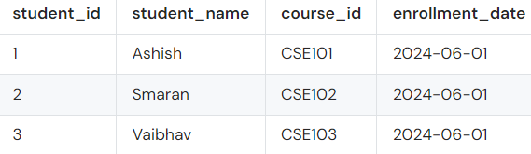

PART B:

SET TRANSACTION ISOLATION LEVEL REPEATABLE READ;

START TRANSACTION;

SELECT enrollment_date

FROM StudentEnrollments

WHERE student_id = 1;

START TRANSACTION;

UPDATE StudentEnrollments

SET enrollment_date = '2024-07-10'

WHERE student_id = 1;

COMMIT;

SELECT enrollment_date

FROM StudentEnrollments

WHERE student_id = 1;

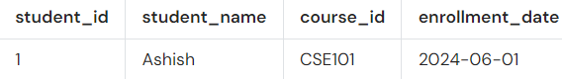

PART C:

START TRANSACTION;

UPDATE StudentEnrollments

SET enrollment_date = '2024-07-15'

WHERE student_id = 1;

START TRANSACTION;

SELECT enrollment_date

FROM StudentEnrollments

WHERE student_id = 1

FOR UPDATE;

START TRANSACTION;

UPDATE StudentEnrollments

SET enrollment_date = '2024-07-15'

WHERE student_id = 1;

START TRANSACTION;

SELECT enrollment_date

FROM StudentEnrollments

WHERE student_id = 1;

